EEET2481|EEET2657 Embedded System Design and Implementation

Semester 2, 2025

Assignment 3: Group Project –Supporting Document

Group 2
Student number | Name
s4067934 | Truong Kiem Minh
s4038330 | Tran Nguyen Bao Hoc

Lecturer: Thanh Pham

I declare that in submitting all work for this assessment, we have read, understood and agreed to the content and expectations of Assessment Declaration as specified in https://www.rmit.edu.vn/students/my-studies/assessment and-exams/assessment

- A Finite State Machine (FSM) state diagram
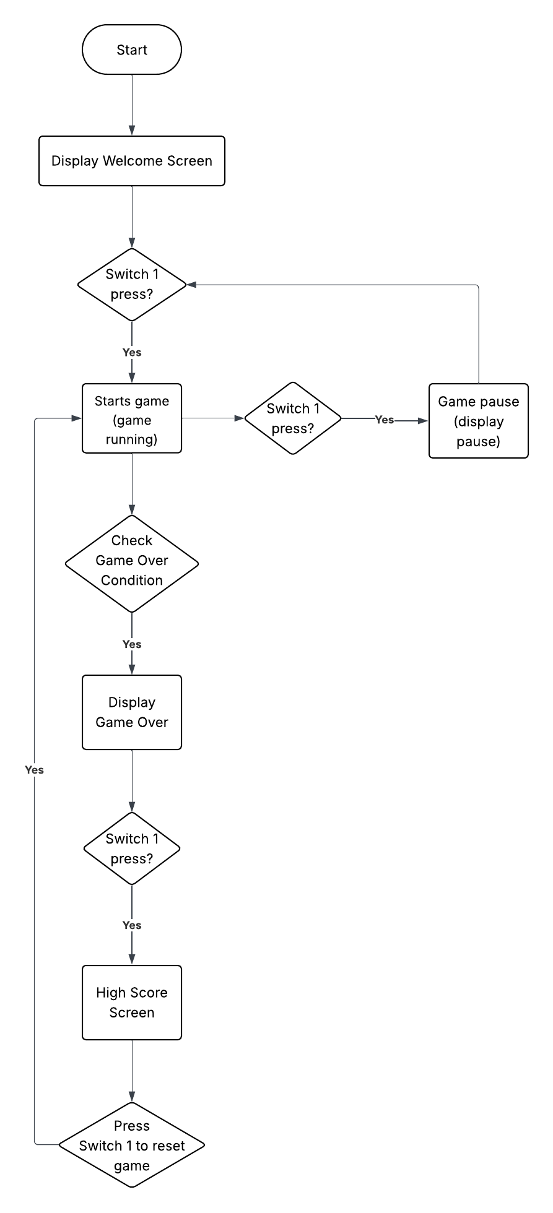
- Design approach
Project context & our goal
This project designs a simple Tetris game for the NuMaker-PFM-M487 board, utilizing the ILI9341 LCD, hardware buttons, and joystick. The goals of our group were: provide a friendly GUI, including a welcome screen, clean game UI (game scene and game over scene); implement robust input handling from physical controls; keep the game logic and hardware drivers operating well.
Initial plan & decision
We began with the course tutorials and decided to use the recommended setup of Tutorial 9's AppWizard, which gives a convenient tool to design GUI screens and support for our LCD's operations. But during testing and developing, we determined that the setup for Tutorial 8's LCD driver approach (using direct EBI writes to the ILI9341 in EBI_LCD_Module.c) was simpler and gave us better control and support for the screen's transitions required by the game logic.
Why do we give up using AppWizard?
AppWizard is excellent for static screens, but it expects to manage the entire GUI lifecycle. The Tetris game needs frequent, small, deterministic pixel updates (per-tile redraws every few frames). We also do not have enough time to research the documentation of the Wizard application to use its functions. Instead, using the direct LCD API (Tutorial 8), let us:
- Perform efficient partial updates (changed tiles).
- Simplify timing and ISR interactions (we control exactly when pixel bursts happen during Timer ticks, safe time).
- Maintain precise alignment with our game coordinate system.
Hybrid approach:
Rather than discard AppWizard completely, we exported the artwork (welcome background and frame) and converted those images into raw RGB565 bitmap arrays stored as static resources in firmware. These arrays serve as the welcome screen and decorative UI elements, while runtime rendering of tiles (moving pieces, score, next block, etc. - dynamic scenes) uses the LCD driver. This hybrid approach gives the best of both: attractive UI art from AppWizard and low-latency drawing for gameplay.
Software structure & modularity
- BSP & drivers (EBI_LCD_Module.c): (LCD initialize & low-level pixel write), GPIO, and timer initialize.
- Display layer (UIDesign.c & backgroundScreenPlay & WelcomeScreen.c & a part of LogicGame.c): draws static bitmaps, maps game tiles with pixel rectangles, and implements partial-redraw logic plus next-piece / information panel updates.
- Game logic (LogicGame): deterministic engine (spawn, move, rotate blocks, scoring, etc.).
- Control & FSM (main + ISR + small FSM): that controls WELCOME → RUNNING → PAUSED → GAME_OVER transitions.
This separation makes testing, debugging and making changes easier.
Tradeoffs & final decision
We exchanged some more manual code for determinism and performance in the rendering loop. Static screens are rendered from RGB565 bitmaps (array), and gameplay uses partial redraws for speed. Timers enable deterministic tick and debounce management with ISRs kept light. This approach Added coding effort, but simpler and provides predictable timing, responsive input, and smooth rendering.

- Waveform Measurement

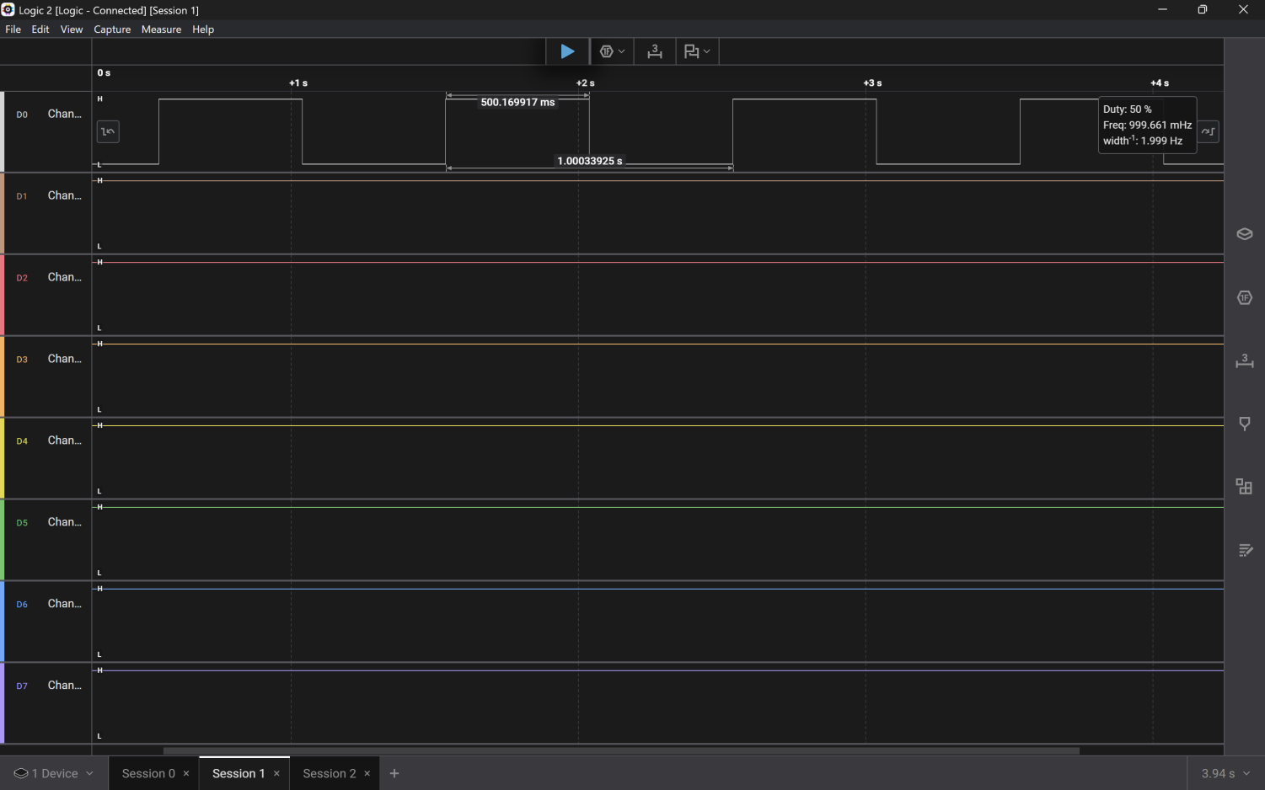
Figure 1: Timer1, block drops speed level 1
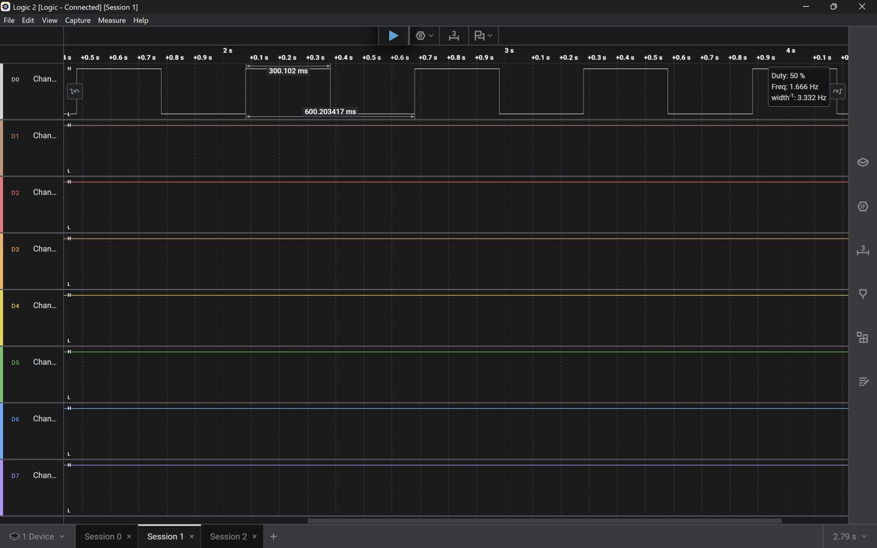
Figure 2: Timer1, block drops speed level 5
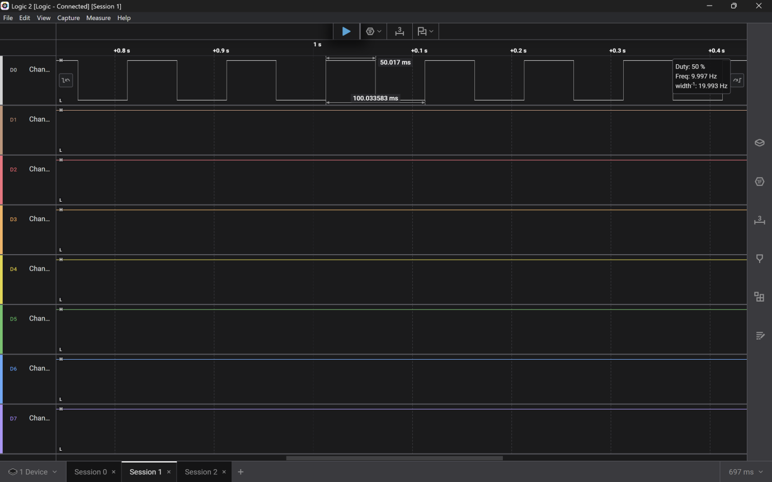
Figure 3: Timer1, block drops speed level 10

